**Research**

***Natural gas***

*Energy Grid North*

|  |
| --- |
| **Datum : 20-04-2021** |
| **Versie : 1** |
| **Status : Start** |
| **Auteur : Aydin, F.** |

# Introduction

The aim of this research is to gather information about the energy production from natural gas. Natural gas is also used to generate electricity. The most commonly used method - to generate energy with natural gas - is by combustion. Heat is released when natural gas is burned. This heat converts water into steam and the steam sets a turbine in motion and this will generate energy.

**Introduction** **2**

**Questions and methods** **3**

**How much natural gas energy does the northern region produce?** **4**

**How to calculate from natural gas to energy?** **6**

**Conclusion** **7**

**Appendix** **8**

# Questions and methods

Main question: **What influence does natural gas have on energy production in the north of the netherlands?**

Sub questions:

* **How much natural gas energy does the northern region produce?**
* **How to calculate from natural gas to energy?**

Methods:

* + Library
    - Literature study (read different studies)

# How much natural gas energy does the northern region produce?

First we will take a look at the natural gas extraction locations. 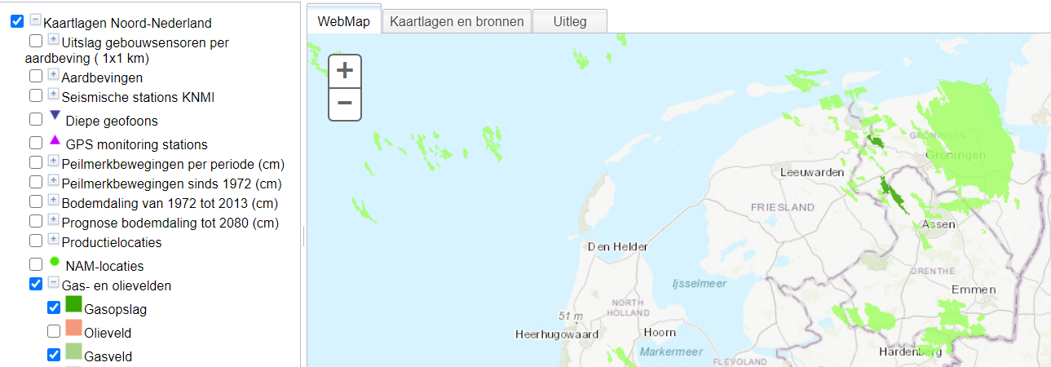

The light green fields are extraction locations and the dark green locations are gas storages. From this image we can see that Gronigen extracts most of the natural gas production.

The figures for gas extraction are given in normal cubic meters (Nm³). A normal cubic meter is an amount of gas that occupies a volume of 1 cubic meter at a temperature of 0 ° C and an absolute pressure of 1.01325 bar.

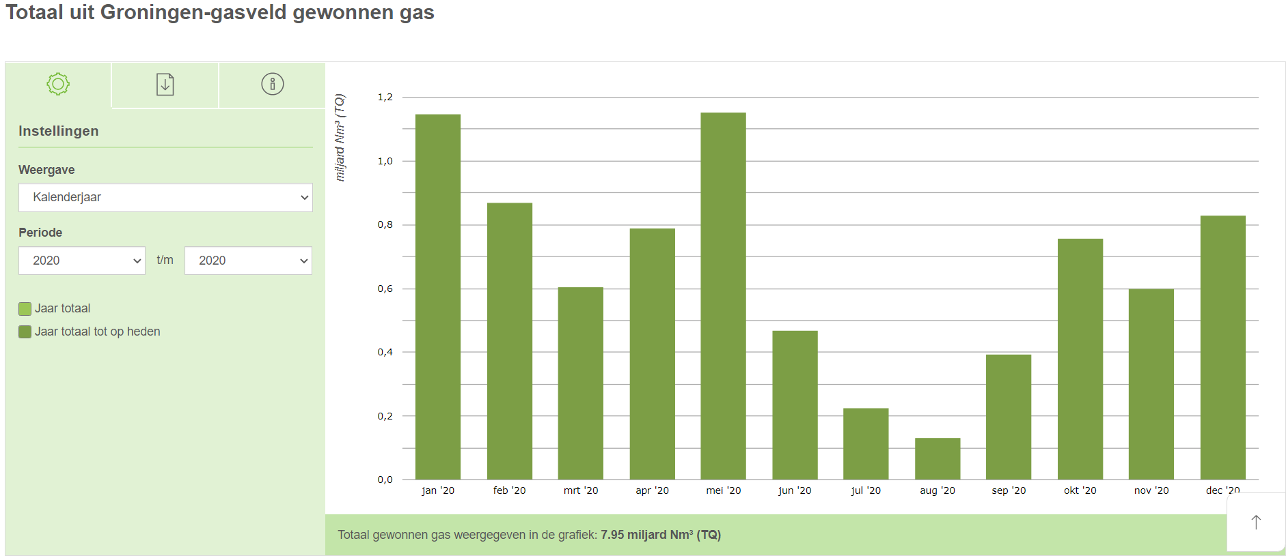

Groningen extracted 7.95 billion Nm3 in 2020.

Due to technical circumstances we cannot obtain certain data via NAM.

|  |
| --- |
| Er worden aanpassingen gedaan in de ICT-structuur die productiecijfers aanlevert voor Feiten & Cijfers voor onze gas- en oliewinning op land en op zee (exclusief het Groningen-veld). De cijfers zijn tijdelijk offline gehaald. Wanneer de aanpassingen gereed zijn, worden de cijfers weer teruggeplaatst. Het is onduidelijk hoe lang dit duurt. Houd deze pagina in de gaten voor updates. |

We will use some older data from other sources instead.

Friesland extracted 5.1 billion Nm3 in 2018

Drenthe extracted 1.3 billion Nm3 in *2020*

“The eleven gas fields in Drenthe are almost empty. The company (NAM) expects to pump up between 1.3 and 3.5 billion Nm3 of gas from it until 2028.” We will use this source because there is no other information that can be found.

# How to calculate from natural gas to energy?

1 standard cubic meter of gas (Nm3) has an upper value of 35.17 MJ (megaJoule)

1 kWh has an energy content of 3.6 MJ.

Calculation

1 Nm3 corresponds to 35.17 MJ / 3.6 MJ = **9.769 kWh** = 9.769 / 1000 = **0.0097694 MWH**

According to Statistics Netherlands, 26.43% of the total natural gas extraction is used for energy production.

|  |  |  |  |
| --- | --- | --- | --- |
| Province | Nm3 | 26.43% | MWH |
| Groningen | 7.950.000.000 | 2.101.185.000 | 20.527.410,13 |
| Friesland | 5.100.000.000 | 1.347.930.000 | 13.168.527,25 |
| Drenthe | 1.300.000.000 | 343.590.000 | 3.356.683,42 |
| Total | 14.350.000.000 | 3.792.705.000 | 37.052.620,80 |

In the year 2020, the Netherlands had a net electricity production of 70,848,000 MWH from natural gas according to Statistics Netherlands. This means that the northern region provides 52.3% of the total production.

# Conclusion

During this research it became clear that the northern region provides 52.3% of natural gas energy for the whole of the netherlands. A lot of natural gas is extracted in the northern region. Research also showed that a large amount was extracted from the North Sea. We have not included this as the northern region because we only focus on the 3 provinces (Friesland, Groningen and Drenthe).

What can we do with this information?

We can now show a list of the produced natural gas energy. In addition, we can create simulations ourselves with the formula. We will use this in the gas service.

# Appendix

CBS Statline. (z.d.). CBS. Geraadpleegd op 22 april 2021, van <https://opendata.cbs.nl/#/CBS/nl/dataset/00372/table>

De Energieconsultant B.V. (2019, 31 juli). Omrekening van m3 (n) naar kWh. De Energieconsultant. <https://www.energieconsultant.nl/energiemarkt/energie-berekeningen-uit-de-praktijk/omrekening-van-m3-n-naar-kwh/>

NAM. (z.d.-a). Gas- en oliewinning. Geraadpleegd op 20 april 2021, van <https://www.nam.nl/feiten-en-cijfers/gaswinning.html#iframe=L2VtYmVkL2NvbXBvbmVudC8_aWQ9Z2Fzd2lubmluZyN0YWItdGFiLXNldHRpbmdzLTk0NjcwMjUyNTBiNDRjMDI5YjkxNDYxYzY3NTZmMWMz>

NAM. (z.d.-b). Locaties en activiteiten. Geraadpleegd op 20 april 2021, van <https://www.nam.nl/gas-en-oliewinning/locaties-en-activiteiten.html#iframe=L21hcHMvZGVmYXVsdC8>

Natuurkunde.nl - verschil tussen m3 en Nm3. (z.d.). Stichting natuurkunde.nl. Geraadpleegd op 20 april 2021, van <https://www.natuurkunde.nl/vraagbaak/12925>

Risico’s aardbevingen in Drents gaswinningsplan niet duidelijk. (2020, 23 december). Binnenlands Bestuur. <https://www.binnenlandsbestuur.nl/bestuur-en-organisatie/nieuws/risico-op-aardbevingen-bij-gaswinning-drenthe.15526720.lynkx>

Toren, N. (2020, 22 januari). De strijd tegen gaswinning heeft zich nu ook verplaatst naar Friesland. Trouw. <https://www.trouw.nl/nieuws/de-strijd-tegen-gaswinning-heeft-zich-nu-ook-verplaatst-naar-friesland~be2557cf/?referrer=https%3A%2F%2Fwww.google.com%2F>